**Comparison of LSTM, BiLSTM, GRU, BiGRU, and CNN Models**

Classification Analysis of Sentiment on Tweets Regarding President Putin's Participation in Indonesia's G20 with the BiGRU Method

# **LSTM**

1. LSTM Model

def model_lstm(num_words, embedding_dim, maxlen):

    tf.random.set_seed(123)

    lstm_dim = 32

    dense_dim = 6

    modelLSTM = tf.keras.Sequential([

        tf.keras.layers.Embedding(num_words, embedding_dim, input_length=maxlen),

        tf.keras.layers.LSTM(lstm_dim),

        tf.keras.layers.Dense(dense_dim, activation='relu'),

        tf.keras.layers.Dense(3, activation='softmax')

    ])

    modelLSTM.compile(loss='sparse_categorical_crossentropy',

                  optimizer=tf.keras.optimizers.Adam(learning_rate=1e-4),

                  metrics=['accuracy'])

    return modelLSTM

modelLSTM = model_lstm(NUM_WORDS, EMBEDDING_DIM, MAXLEN)

modelLSTM.summary()

1. Model.fit

historyLSTM = modelLSTM.fit(train_padded_seq,

                            train_label_seq,

                            epochs=100,

                            validation_data=(val_padded_seq, val_label_seq))

1. Results

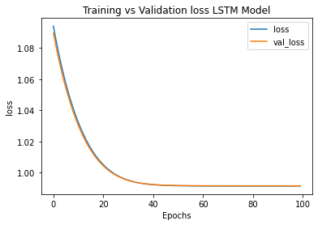

*Training and Validation Loss for LSTM Model*

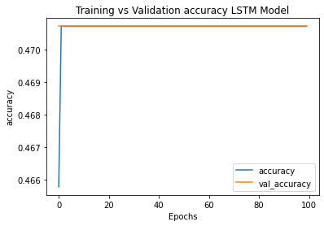

*Training and Validation Accuracy for LSTM Model*

Best Validation Accuracy : 0.4707

On Epoch : 1

Confusin Matrix :

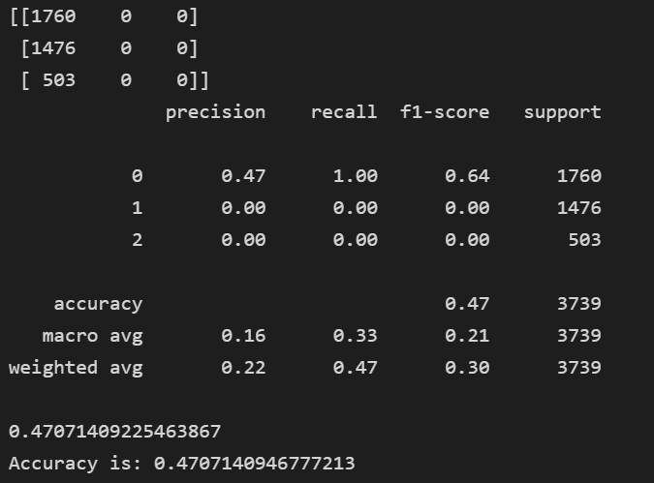 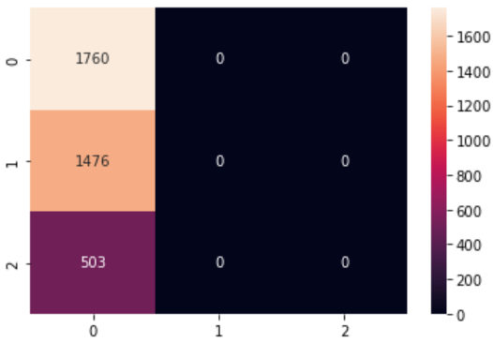

# BiLSTM

1. BiLSTM Model

def model_BiLSTM(num_words, embedding_dim, maxlen):

    tf.random.set_seed(123)

    lstm_dim = 32

    dense_dim = 6

    modelBiLSTM = tf.keras.Sequential([

        tf.keras.layers.Embedding(num_words, embedding_dim, input_length=maxlen),

        tf.keras.layers.Bidirectional(tf.keras.layers.LSTM(lstm_dim)),

        tf.keras.layers.Dense(dense_dim, activation='relu'),

        tf.keras.layers.Dense(3, activation='softmax')

    ])

    modelBiLSTM.compile(loss='sparse_categorical_crossentropy',

                  optimizer=tf.keras.optimizers.Adam(learning_rate=1e-4),

                  metrics=['accuracy'])

    return modelBiLSTM

modelBiLSTM = model_BiLSTM(NUM_WORDS, EMBEDDING_DIM, MAXLEN)

modelBiLSTM.summary()

1. ModelCheckpoint & Model.fit

mc = ModelCheckpoint('classifier-putinG20-BiLSTM_01.h5', monitor='val_accuracy', mode='max', verbose=1, save_best_only=True)

historyBiLSTM = modelBiLSTM.fit(train_padded_seq,

                                train_label_seq,

                                epochs=100,

                                callbacks=[mc],

                                validation_data=(val_padded_seq, val_label_seq))

1. Result

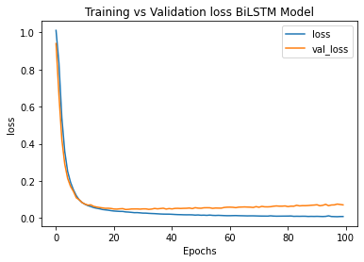

*Training and Validation Loss for BiLSTM Model*

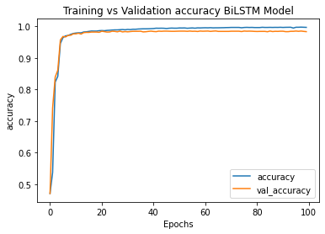

*Training and Validation Accuracy for BiLSTM Model*

Best Validation Accuracy : 0.98583

On Epoch : 65

Confusin Matrix :

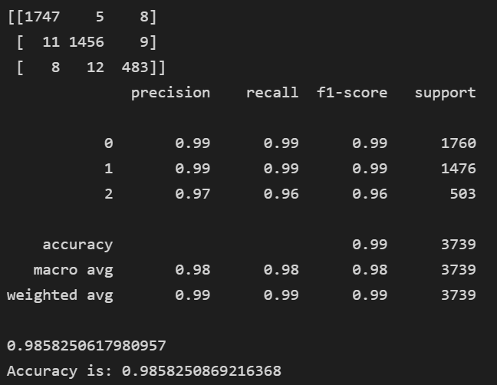 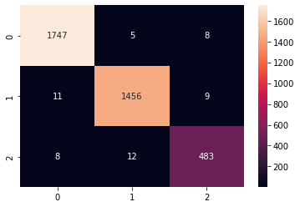

# GRU

1. GRU Model

def model_GRU(num_words, embedding_dim, maxlen):

    tf.random.set_seed(123)

    gru_dim = 32

    dense_dim = 6

    modelGRU = tf.keras.Sequential([

        tf.keras.layers.Embedding(num_words, embedding_dim, input_length=maxlen),

        tf.keras.layers.GRU(gru_dim),

        tf.keras.layers.Dense(dense_dim, activation='relu'),

        tf.keras.layers.Dense(3, activation='softmax')

    ])

    modelGRU.compile(loss='sparse_categorical_crossentropy',

                  optimizer=tf.keras.optimizers.Adam(learning_rate=1e-4),

                  metrics=['accuracy'])

    return modelGRU

modelGRU = model_GRU(NUM_WORDS, EMBEDDING_DIM, MAXLEN)

modelGRU.summary()

1. Model.fit

historyGRU = modelGRU.fit(train_padded_seq,

                        train_label_seq,

                        epochs=100,

                        validation_data=(val_padded_seq, val_label_seq))

1. Result

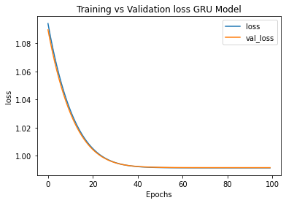

*Training and Validation Loss for GRU Model*

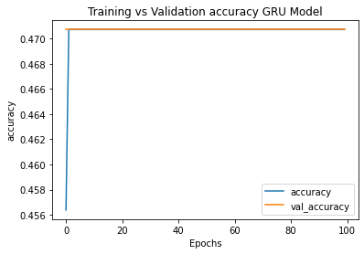

*Training and Validation Accuracy for GRU Model*

Best Validation Accuracy : 0.4707

On Epoch : 1

Confusin Matrix :

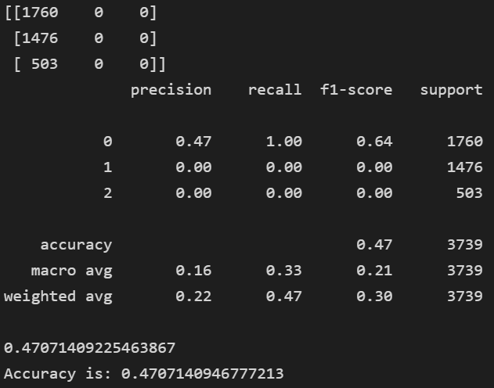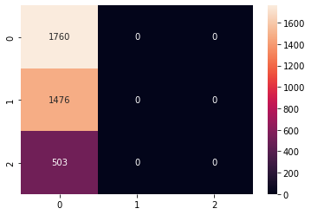

# BiGRU

1. BiGRU Model

def model_BiGRU(num_words, embedding_dim, maxlen):

    tf.random.set_seed(123)

    gru_dim = 32

    dense_dim = 6

    modelBiGRU = tf.keras.Sequential([

        tf.keras.layers.Embedding(num_words, embedding_dim, input_length=maxlen),

        tf.keras.layers.Bidirectional(tf.keras.layers.GRU(gru_dim)),

        tf.keras.layers.Dense(dense_dim, activation='relu'),

        tf.keras.layers.Dense(3, activation='softmax')

    ])

    modelBiGRU.compile(loss='sparse_categorical_crossentropy',

                  optimizer=tf.keras.optimizers.Adam(learning_rate=1e-4),

                  metrics=['accuracy'])

    return modelBiGRU

modelBiGRU = model_BiGRU(NUM_WORDS, EMBEDDING_DIM, MAXLEN)

modelBiGRU.summary()

1. ModelCheckpoint & Model.fit

mc = ModelCheckpoint('classifier-putinG20-BiGRU_04.h5', monitor='val_accuracy', mode='max', verbose=1, save_best_only=True)

historyBiGRU = modelBiGRU.fit(train_padded_seq,

                            train_label_seq,

                            epochs=100,

                            callbacks=[mc],

                            validation_data=(val_padded_seq, val_label_seq))

1. Result

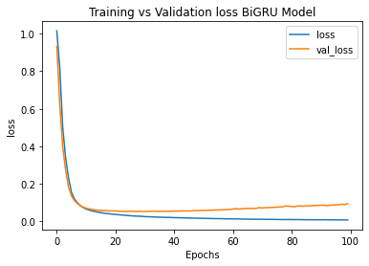

*Training and Validation Loss for BiGRU Model*

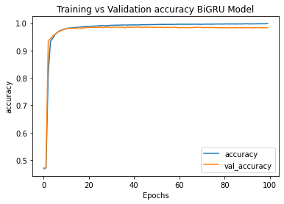

*Training and Validation Accuracy for BiGRU Model*

Best Validation Accuracy : 0.9864

On Epoch : 29

Confusin Matrix :

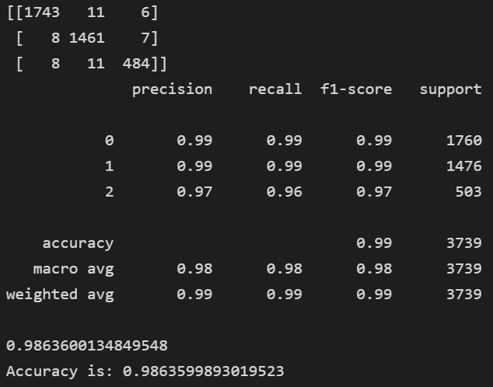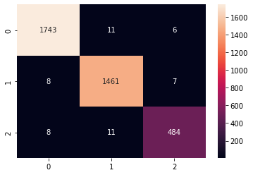

# CNN

1. CNN Model

def model_conv(num_words, embedding_dim, maxlen):

    tf.random.set_seed(123)

    filters = 64

    kernel_size = 3

    dense_dim = 6

    modelConv = tf.keras.Sequential([

        tf.keras.layers.Embedding(num_words, embedding_dim, input_length=maxlen),

        tf.keras.layers.Conv1D(filters, kernel_size, activation='relu'),

        tf.keras.layers.GlobalAveragePooling1D(),

        tf.keras.layers.Dense(dense_dim, activation='relu'),

        tf.keras.layers.Dense(3, activation='sigmoid')

])

    modelConv.compile(loss='sparse_categorical_crossentropy',

                  optimizer=tf.keras.optimizers.Adam(learning_rate=1e-4),

                  metrics=['accuracy'])

    return modelConv

modelConv = model_conv(NUM_WORDS, EMBEDDING_DIM, MAXLEN)

modelConv.summary()

1. ModelCheckpoint & Model.fit

mc = ModelCheckpoint('classifier-putinG20-CNN_01.h5', monitor='val_accuracy', mode='max', verbose=1, save_best_only=True)

historyConv = modelConv.fit(train_padded_seq,

                            train_label_seq,

                            epochs=100,

                            callbacks=[mc],

                            validation_data=(val_padded_seq, val_label_seq))

1. Result

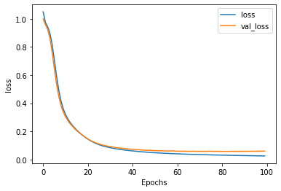

*Training and Validation Loss for CNN Model*

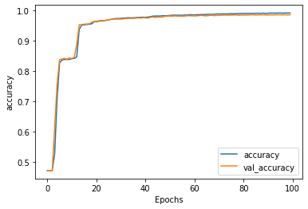

*Training and Validation Accuracy for CNN Model*

Best Validation Accuracy : 0.98583

On Epoch : 94

Confusin Matrix :

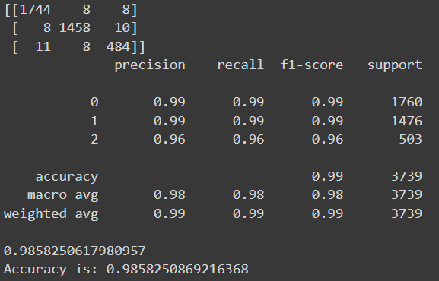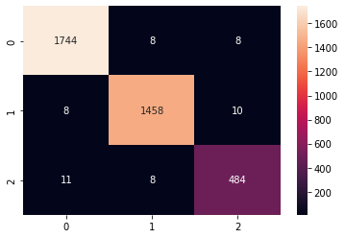

**SUMMARY**

|  |  |  |  |  |  |
| --- | --- | --- | --- | --- | --- |
| ***Model (Top Layer)*** | ***LSTM*** | ***BiLSTM*** | ***GRU*** | ***BiGRU*** | ***CNN*** |
| **Optimizer** | Adam | Adam | Adam | Adam | Adam |
| **Learning Rate** | 1e-4 | 1e-4 | 1e-4 | 1e-4 | 1e-4 |
| **Best Validation Accuracy** | 0.4707 | 0.98583 | 0.4707 | 0.9864 | 0.98583 |
| **On Epoch** | 1 | 65 | 1 | 29 | 94 |
| **Graph Train & Val Loss** |  |  |  |  |  |
| **Graph Train & Val Accuracy** |  |  |  |  |  |
| **Confusion Matrix** |  |  |  |  |  |